**API**

[Build a Django REST API with the Django Rest Framework. Complete Tutorial.](https://www.youtube.com/watch?v=c708Nf0cHrs)

[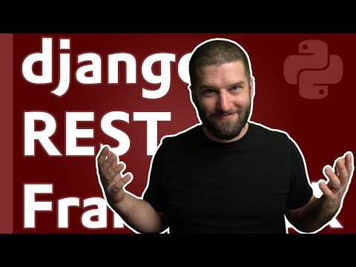](https://www.youtube.com/watch?v=c708Nf0cHrs)

[Building API's with Python & Django REST Framework](https://www.youtube.com/watch?v=c0x_AaPjNCY)

[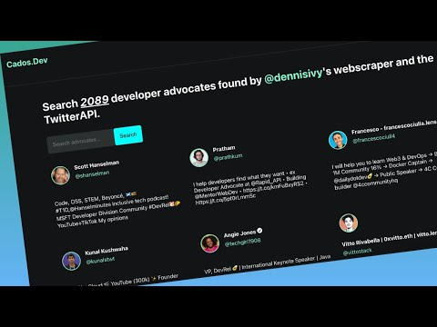](https://www.youtube.com/watch?v=c0x_AaPjNCY)